  2012-2013 | Middle School  Family & Consumer Science  Teachers |   Albuquerque  Public Schools

Invitation to all MS FACS teachers to attend a monthlycome and share meeting.
It will be at Flying Star at Wyoming and Paseo Del Norte from 4-6pm. Come to
any meeting you can and bring copies of lessons and items to share, specifically Common Core CTE lessons.
The Meetings were changed to meet the requirement of having Ms.Sanchez present from Curriculum and Instruction per Sheryl Williams.

NEW DATES- PLEASE CHANGE YOUR CALENDAR
August 22 Wednesday | October 11, Thursday
September 11, Tuesday | November 15, Thursday

Teacher | Phone | Email | School | Name of Programs
Leesa Trapp | 857-9282 x208 | trapp@aps.edu | Desert Ridge MS | Intro to FACS, Exploratory FACS
Melissa Blaine | 507-0852  299-2113 | queenblaine@aol.com  blaine@aps.edu | Grant MS | Intro to FACS,  Exploratory FACS
Cindy Dennis | 897-0101 x22052 | Schmidt_c@aps.edu  dennis_c@aps.edu | James Monroe MS | Foods,  Creative Sewing, Exploratory Life Skills
Diana Rael | 833-7540 x-7157 | tortilla4five@aol.com  rael_dt@aps.edu | Jimmy Carter MS | Consumer Decisions, Intro to FACS, Exploratory FACS
Karen Holmstead | 898-1492 x-21120 | homstead@aps.edu | LBJ MS | Intro to FACS, Exploratory FACS
Linda Hansen | 299-4735 | hansen_li@aps.edu | Madison MS | Intro to FACS,  Foods,  Exploratory FACS
Holly Naeb | 281-3316 | naeb@aps.edu | Tony Hillerman MS | Intro to FACS,  Exploratory FACS
Barbara Mraz | 255-8691 x401 | mraz@aps.edu | Jeffereson MS | Intro to Facs  Exploratory FACS
Lillie Fitzpatrick |  | fitzpatrick_l@aps.edu | Eisenhower MS | Exploratory FACS,  Sewing,  Foods
Special Resources:
Irma Ramirez | 855-5282 | ramirez_i@aps.edu | APS | Secretary CTE office
Karisten Sanchez |  | sanchez_kr@aps.edu | APS | Curriculum & Instruction

Minutes MS FACS Teachers
August 22, 2012 Flying Star Wyoming & Paseo Del Norte

Present: Lillie Fitzpatrick, Melissa Blaine, Karen Homstead, Leesa Trapp, Cindy Dennis,Diana Rael.
Absent: Barbara Mraz, Linda Hansen, Holly Naeb.
Minutes provided by Melissa Blaine.

All activities and lessons shared include a component that meet the Core Content standards for schools in Reading, Writing and Math.

1. Melissa Blaine shared A. “It's All About Me” collage activity. Students must use ACE to write 2 sentences for each section, then add collage pictures from the collage guideline H.O. Students use this guideline as a check off list for pictures to create their collage. Rubric provided. B. Article written for Choices magazine called “Multi-Racial and Proud” to go with the Self and Family unit. Students read out loud in round robin format, students may pass one time. Then students discuss with class- “who they are and proud to be!”
C. Article from Scholastic Action magazine on “Are you Eating Slime” for foods unit- students read out loud then use the 4 part Chart provided to write supporting details for the main idea of the article. D. From the Scholastic Action Magazine for Teens is a Debate issue for Consumerism/clothing Unit. Students read the one page article and then both sides of the debate. In teams of two, students must choose a side and present their argument to the class.
- Karen Homstead shared A. Karen color codes each of her hand outs for 6th, 7th, 8th. This makes it easier to collect and grade work. B. Within the 1st 2 weeks of school she takes her students to the computer lab for this 3 day lesson on career exploration/Math. Kids go to DOL website and complete the 180 question survey (interest pro-filer). They fill in their scores and Pick their top 3. They then have to choose 3 occupations, annual entry wage, average wage and experienced wage along with calculating statewide hourly wage averages. To extend this activity for 7/8th graders- they would spend a day on their choice of job description and write about it all. They would also read and learn about the Child labor laws, minimum wage and work permits. Lastly, they would identify the career cluster and what classes to take in High school. The Raced rubric would be a written paragraph : what did they learn and where are they going to for their future. All information would be posted as a Bulletin Board for open house. If sharing computers, students are given a career/vocabulary word search.
- Diana Rael shared she is revamping her lessons this year due to the fact she has no money for her foods classes. She is also teaching Intro to FACS.
- Cindy Dennis shared A. a book called: EAT YOUR MATH HOMEWORK ISBN # 978-1-57091-780-6 Recipes for Hungry Minds $7.95. Each recipe taught provides math core concepts and would be fun to try several of the recipes in class. B. She also shared a 3 fold flier from the public library called: Culinary Mystery. It lists novels relating to foods. Many of the novels are appropriate for our middle school students.
- Karen Homstead shared A. the fact she purchased individual induction stove tops for each of her kitchens along with pots and pans. This is the newest technology for cooking and would have the students learn the technology, cook and compare with conventional cooking styles. She also stated that she would like to purchase the wall mounted Induction oven from Turbo Chef. Com. (cooks cookies in 4 minutes, turkey in ½ hour....saves time and nutritional integrity of each food. B. Karen uses consumer reports magazine for breakfast cereals and will bring them next time. C. Foods unit requirement is to learn all the abbreviations, equivalents, and measurements before anyone can go into the foods lab. She uses flash cards, demonstrations with water and ingredients in measuring tools, and lastly a fold-able that she recreated. Absolutely everyone must pass these tests 0 or 100% before going to kitchen for food labs.
- Leesa Trapp shared A. a packet on employ-ability and work ethics. Essential question- How do you get hired? Give work ethics packet- start with what do they value and how does this connect to work. Students must consider who they admire and what their ethics are. Complete Work Values Exercises (Rate 1-5) Success in the classroom means if you get the job or if you keep the job. Things are not handed to you in life. Develop critical thinking skills ask they go through the packet. B. Sewing unit- Student teacher created a large poster size sewing machine with velcro dots to hold the names of each parts of the machine. Create a game and study as a class.
- Lilly Fitzpatrick came to this first meeting and the MS FACS teachers offered support and help with all lessons. Lilly simply asked how do you manage different levels of ability in the sewing lab. Several suggestions were shared. She was also invited to come and visit each school to see first hand.
- Go to www.Joannes.com to get your discount card.
- Melissa Blaine will bring the wish list that she sends out to share and the pyramid template for self unit.
- Next meeting will be SEPTEMBER 11, TUESDAY 4-6PM.

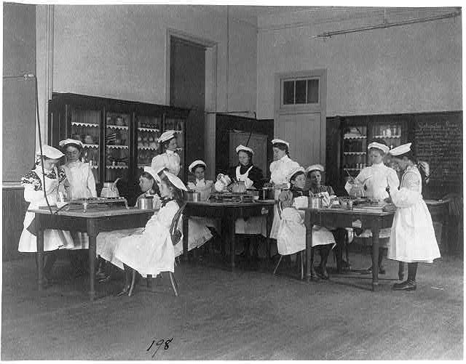
1900's Home Economics classes
Teaching how to make breakfast

