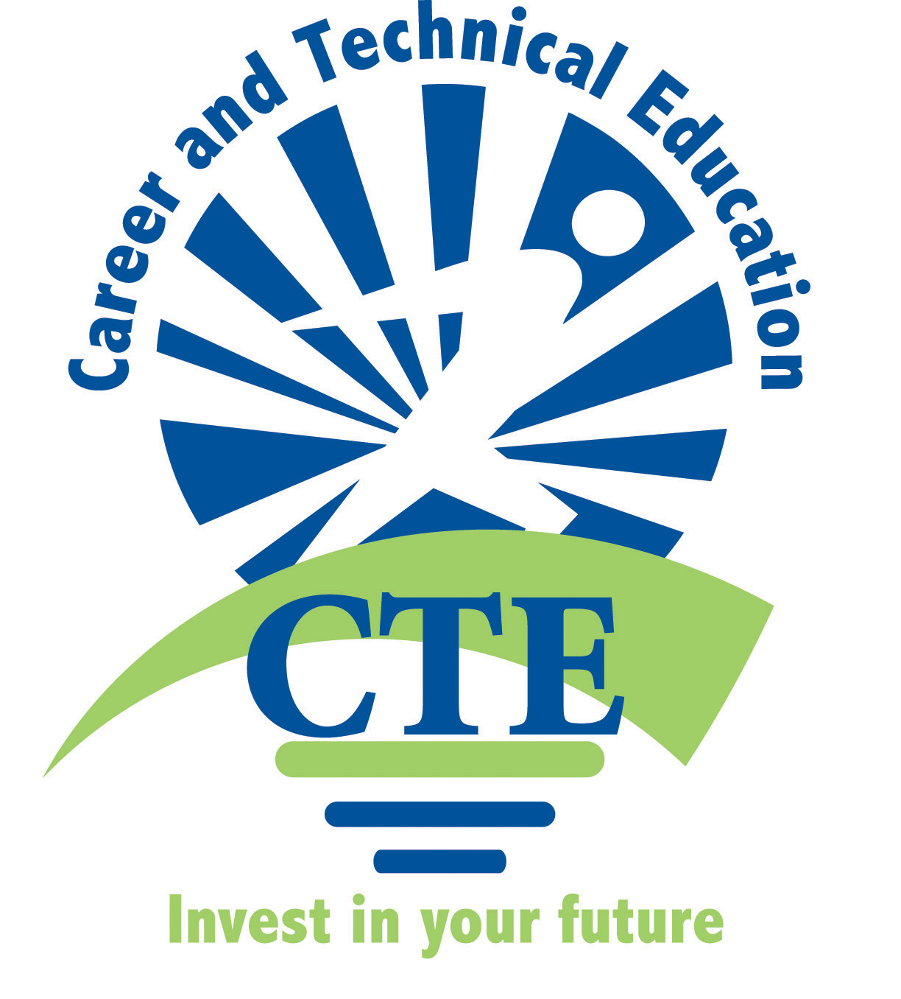  2012-2013 | Middle School  Family & Consumer Science  Teachers |   Albuquerque  Public Schools

Invitation to all MS FACS teachers to attend a monthly come and share meeting.
It will be at Flying Star at Wyoming and Paseo Del Norte from 4-6pm. Come to
any meeting you can and bring a copy of lessons and items to share,
specifically Common Core CTE lessons.
Teacher | Phone | Email | School | Name of Programs
Leesa Trapp | 857-9282 x208 | trapp@aps.edu | Desert Ridge MS | Intro to FACS, Exploratory FACS
Melissa Blaine | 507-0852  299-2113 | queenblaine@aol.com  blaine@aps.edu | Grant MS | Intro to FACS,  Exploratory FACS
Cindy Dennis | 897-0101 x22052 | Schmidt_c@aps.edu  dennis_c@aps.edu | James Monroe MS | Foods,  Creative Sewing, Exploratory Life Skills
Diana Rael | 833-7540 x-7157 | tortilla4five@aol.com  rael_dt@aps.edu | Jimmy Carter MS | Consumer Decisions, Intro to FACS, Exploratory FACS
Karen Holmstead | 898-1492 x-21120 | homstead@aps.edu | LBJ MS | Intro to FACS, Exploratory FACS
Linda Hansen | 299-4735 | hansen_li@aps.edu | Madison MS | Intro to FACS,  Foods,  Exploratory FACS
Holly Naeb | 281-3316 | naeb@aps.edu | Roosevelt  MS | Intro to FACS,  Exploratory FACS
Barbara Mraz | 255-8691 x401 | mraz@aps.edu | Jeffereson MS | Intro to Facs  Exploratory FACS
Lillie Fitzpatrick |  | fitzpatrick_l@aps.edu | Eisenhower MS | Exploratory FACS,  Sewing,  Foods
Special Resources:
Irma Ramirez | 855-5282 | ramirez_i@aps.edu | APS | Secretary CTE office
Karisten Sanchez |  | sanchez_kr@aps.edu | APS | Curriculum & Instruction

Minutes MS FACS Teachers
October 11, 2012
Flying Star Wyoming & Paseo Del Norte

Present: Lillie Fitzpatrick, Melissa Blaine, Cindy Dennis, Holly Naeb, Barbara Mraz, Linda Hansen, Kristine Sanchez.
Absent: Leesa Trapp, Diana Rael, Karen Holmstead,
Minutes provided by Melissa Blaine.

All activities and lessons shared include a component that meet the Core Content standards for schools in Reading, Writing and Math.

- Kristine Sanchez of CTE was present for a short time and is currently working on the CTE website. She indicated that we could write our FACS with common core components and have them linked on the website to share with other teachers.
- Everyone shared what they teach:
- Holly Naeb 2 Intro to Facs, 3 Science classes
- Barabara 2 Intro to Facs, 3 Exploratory
- Lillie 4 Intro to Facs, 1 Health
- Melissa 2 Intro to Facs, 3 Exploratory
- Cindy 1 Exploratory, 1 Sewing, 3 foods
- Linda 1 Intro to Facs, 2 foods, 2 Exploratory
- Lillie shared Lang/Arts Common Core lesson. 1 page handout for 6th graders called Find Food Safety Mistakes. Read out loud and Kids write out the mistakes.
- Holly shared L/A and Math Common Core Lesson. At her school the failing SBA point for her students was Measurement so the school is working in this area to help students improve. The lesson was a recipe to make Rice Krispie Treats in the shape of Candy corn for October. Students had to break the recipe into 3 parts and use fractions for measuring. Students had a picture for reference and there was discussion about measuring, what worked and didn’t work as they made the treat. Recipe idea came from Martha Stewart FOOD magazine and was adapted for the class.
- Cindy shared Reading, L/A and Math Common Core Lesson. Reading a Recipe packet had pages to use with students. Parts of Recipe, rewrite a recipe, underline parts of recipe, circle verbs, etc…Granola recipe was used. Added bonus pages of “Bell ringers” worksheets students can work on math skills while food is baking or short amounts of time before the bell rings. The Equal Measurement H.O. is a great reinforcement activity. Cindy uses Adventures in Food text. She shared the tri-fold brochure from Taylor Ranch Library with a list of Culinary Mysteries (books available at the library). She also copied from the JoAnn Fabric website a cute hand sewing free idea sheet to share. Joann.com How to…. Provides lots of lessons and ideas! Cindy also commented on the recent required Oct. CTE meeting and Ivy sent another FACS link. Hopefully, Melissa will be able to forward to everyone.
- Barbara shared Reading and Math Common Core Lesson. She used 2 successful recipes to improve measurement comprehension, which in-turn would support the SBA testing. 1. Everyone at school brought apples; the class prepared them and froze them. They then made empanadas and several other recipes with apples. 2. The class made Basic yeast dough and made mini pizzas and pizza pockets. The cool thing is that period one made the dough for the period 2 and period 3 made it for the next class, etc… this helped because the classes are only 55 minutes long.
- Linda shared Language Arts Common Core Lesson. Students write down their favorite food, restaurant or type of food. Then they had to write a persuasive paragraph encouraging another to try their item or place. This was great practice for the SBA test and was a successful lesson for a substitute. At the end the class could have open discussions about what each student wrote.
- Melissa shared Math and Reading Common Core Lesson. Snack Demonstration Packet was shared. Using a blender use a snickers, chips, and one soda pop- add to the blender as you talk about the nutritional value of each and serving size. Blend it! YUK! Kids love it. Then have them make a healthy snack with apples and yogurt dip. Discuss nutrients and serving size again. You could use any healthy snack you wanted. Melissa also shared the book: Kitchen Math by Susan Brendel, 1997 which has tons of pages that could be used by subs, as fillers and reinforcement activities. www.Justfacs.com was recommended as a resource.

- OPEN DISCUSSION TOPICS:

- In Newest FACS curriculum Guide put out by CTE it is hard to find the resources to go with the lessons. It was decided that we would bring titles of Video’s and DVD resources we use and are willing to share.
- This is the year for FACS Textbook Adoption. Melissa will find out from Sheryl Williams about the process and let everyone know what we need to do. PD said we have the money, but there is confusion about what APS is doing with textbook adoptions at this point.
- For Next meeting: Everyone needs to bring a copy of the Title, Publisher, date and ISBN # for the Textbooks used in their classrooms. This will give us a baseline for our adoption year.
- Linda and Barbara want copies of pages 6-7, 26-27 from Kitchen Math book.
- Some stores are now selling shortening that includes animal fat again. Read the labels.
- The APS district does not support any of the older equipment like overhead projectors or transparencies. We should all be using the latest of technology: White boards, Promethean boards, Elmo-document readers and I-pads.
- When baking Cookies- be aware that if only using margarine they will fall flat. Use ½ margarine and ½ shortening; add extra flour sometimes helps too.
- When doing lesson on hand sewing (sock rabbit or frogs) extend the lesson to include a writing component or measurement with the ruler.
- Date discussed for DECEMBER MEETING: Dec. 6th or 13th- check with Kristine. Will be announced at next meeting: November 15, Thursday.
- Melissa will ask Irma about discarded books and how to get them for Holly and Lillie.
- Melissa will advocate for Eisenhower & Jefferson for their funding by talking with Irma next week. Evidently they are having difficulties accessing their CTE money from Irma/Sheryl Williams at their schools. May need Sheryl to call the principals and locate the allotted amount and remind administrators about the funding for the FACS programs.



