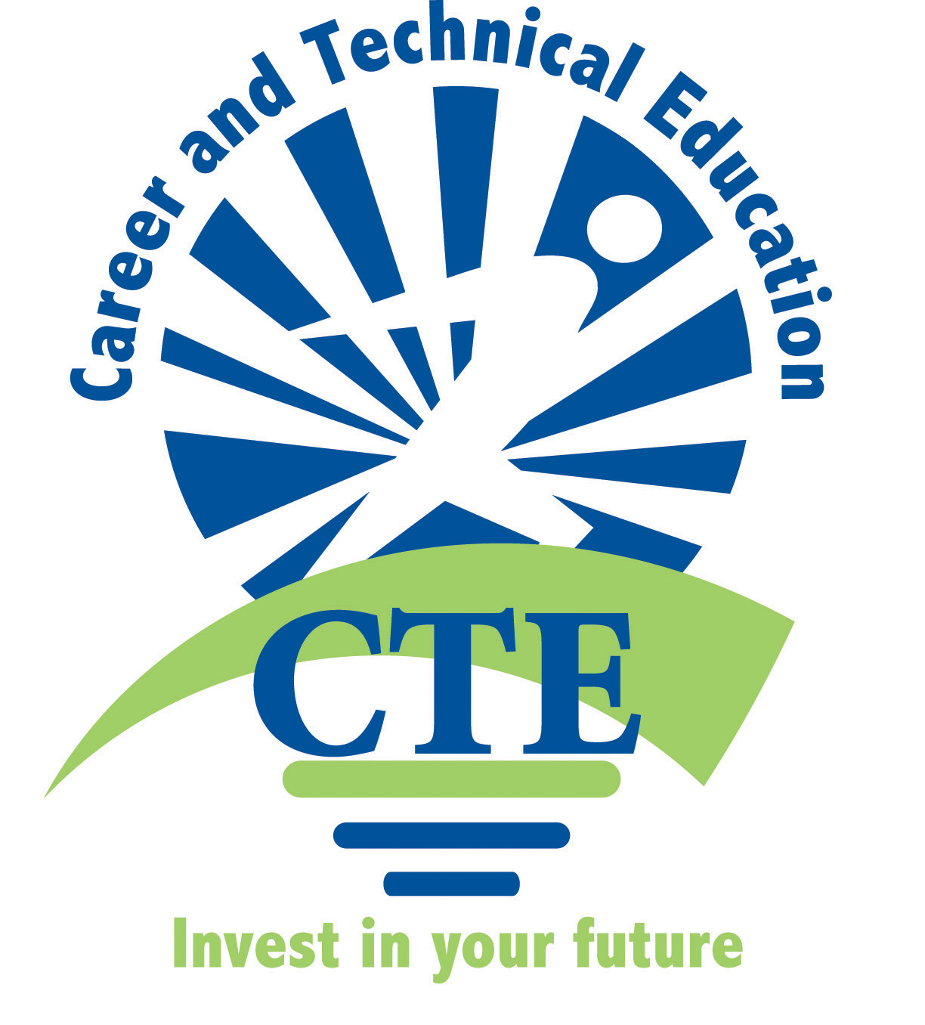  2012-2013 | Middle School  Family & Consumer Science  Teachers |   Albuquerque  Public Schools

Minutes from 11-15-2012
Flying Star on Wyoming
4:00-6:00pm

Present: Linda Hansen, Melissa Blaine, Barbara Mraz, Lillie Fitzpatrick, Diana Rael.
Absent: Leesa Trapp, Karen Homstead, Holly Naeb, Kristine Sanchez, Cindy Dennis.
Minutes provided by Melissa Blaine.

- Everyone will have to send in their own time sheet and remember to write in RED INK! Send them to Irma at the CTE office to process.

- Update: Lillie Fitzpatrick still has not received any funding for the FACS program. Melissa and Lillie will follow up with persistent calls to Irma and Sheryl for assistance with this issue.

- Update: Neither Irma or Sheryl got back with Melissa on whether or not we will be having a textbook adoption this year. Melissa will follow up with calls to Irma and Sheryl on this issue.

- Update: Holly Naeb was able to get textbooks with money from Sheryl Williams and CTE.

- The Textbooks Each teacher uses in their classroom currently:
Lillie at Eisenhower MS: 6th- Discovering Life Skills, 2007. 7/8th -Building Life Skills, 2007 and 7/8th -Applying Life Skills, 2007. Adventures in Foods and Nutrition is used periodically.
Linda at Madison MS: 6th- Discovering Life Skills, 2007. 7/8th -Applying Life Skills, 2007. 6/7/8th- Discovering Foods and Nutrition and Nutrition & Wellness.
Diana Rael at Jimmy Carter MS: 6th- Discovering Foods and Nutrition. 7/8th Applying Life Skills.
Cindy Schmidt at James Monroe MS: 6th- Discovering Life Skills, 2007. 7/8th -Applying Life Skills, 2007. 6/7/8th- Discovering Foods and Nutrition and Nutrition & Wellness.
Barbara Mraz at Jefferson MS: 6th Discovering Foods & Nutrition. Seldom uses Building Life Skills because they are old copies.
Melissa Blaine at Grant MS: 6th Young Living, 2000. 7/8th- Today's Teen, 2000. 6/7/8th- Discovering Food and Nutrition, 2004. Nutrition & Wellness, 2004.
Other teachers were not present to share their texts. All textbooks were published by Glenco- McGraw Hill the District approved publisher for the last adoption year in 2006-7.

- Lillie shared measurement resource with Barbara Mraz.
Measuring in the Kitchen- 18 min. ISBN:0917-159-07-1, 2000, Learning Seed
- Linda Hansen shared 6/7/8 common core Language Arts/reading lesson: Tree Map on Nutrients.
Each student completes their own on a large construction paper and uses Discovering Foods & Nutrition Text book for a resource. Students need to use phrases, not individual words to fill in chart. Then in pairs, students create a Double bubble & web on Wellness-What is in Common-Not Well. Diana Rael uses the Tree Map for her Food classes on Tools in the Kitchen.
- Linda Hansen shared 6/7/8 Common Core Tier II 12 Power Words activity. Three pages, print on card stock and laminate. Cut apart and then set on table for students to match.
- Barbara Mraz shared 6/7/8 Common Core Language Arts lesson: How to Introduce Each other. This lesson is great for student lead conferences and the students enjoy role playing. They even had to introduce the President of the United States.

- Barbara Mraz shared 7/8th Common core Language Arts and Math lesson. Design the Ultimate Outfit. Students use the handout with body shape to create an outfit and cost it. One for boy and one for girl. Barbara brings in tons of the circular clothing fliers for student use and getting the cost. Students also have to write about their outfit, describing it and justifying the cost.
- Lillie Fitzpatrick shared 7/8th Common Core Language Arts Lesson: Peer Editing Report of Disorder or Disease. Students research and write a 1 page report about a disorder or disease. The handout is on how to peer edit and self evaluate. Both tasks are used in the Language arts classes and students are familiar with the process. They need the practice and it helps their writing skills.
- Lillie Fitzpatrick shared 7/8th Common Core Social Studies and Math lesson: World of Spices.
This lesson is tied to SS and World Exploration. In class talk about different spices, learn cost and then do math lesson on cost/ounce. Complete a lab activity with spices on taste and smell.
- Melissa Blaine shared 6th Common Core Language Arts lesson: Sock Frog Creative Stories.
After the hand sewing lesson with students creating sock frogs there is a contest with awards for all the students. Then the students must write a creative story about their frog. They use a web page for the draft, then they write out their final story on a handout. They add a colored picture of themselves and their sock frog. Students can read them out loud to the class for bonus points. Pictures below are from the sock frog contest.
- NOTES: Melissa will bring handout for the directions to make the sock frogs to the next meeting. Linda will bring her instructions for the drawstring bag to the next meeting. Barbara does not have sewing machines and will need to get a copy of the Current CTE FACS Middle School Curriculum Guides from Irma at the CTE office.

- With your handout please include:
Your Name, School, Common Core used, Grade level it is for, Class it is used in and number of days it takes to present the lesson.

Next Meeting will be: Thursday December 6th, 2012 at Flying Star on Wyoming and Paseo.

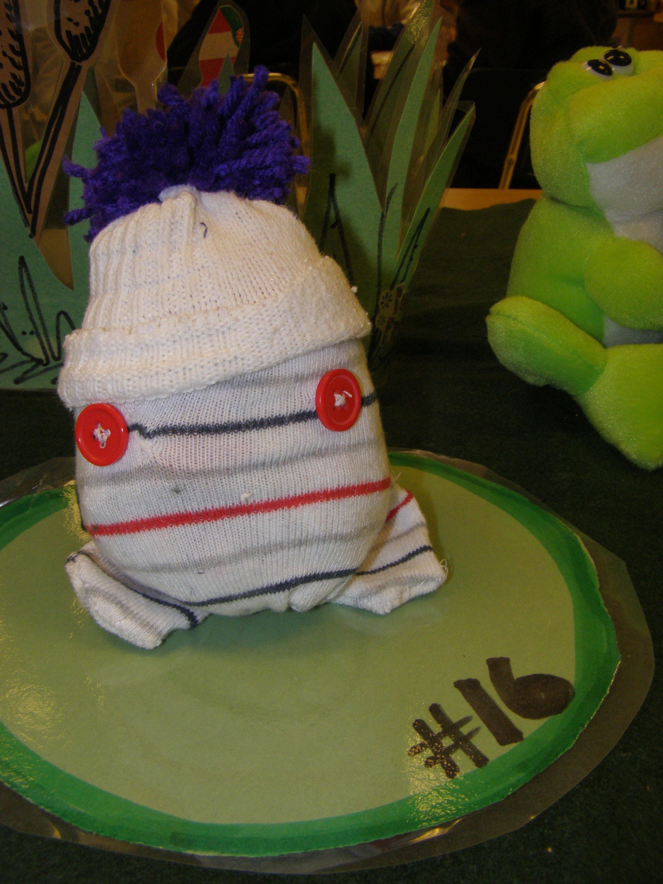  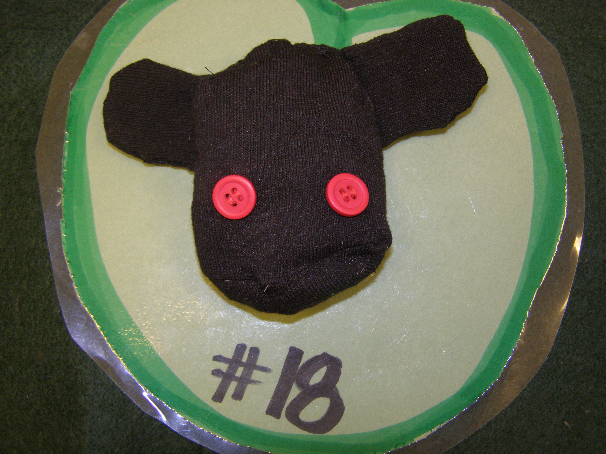  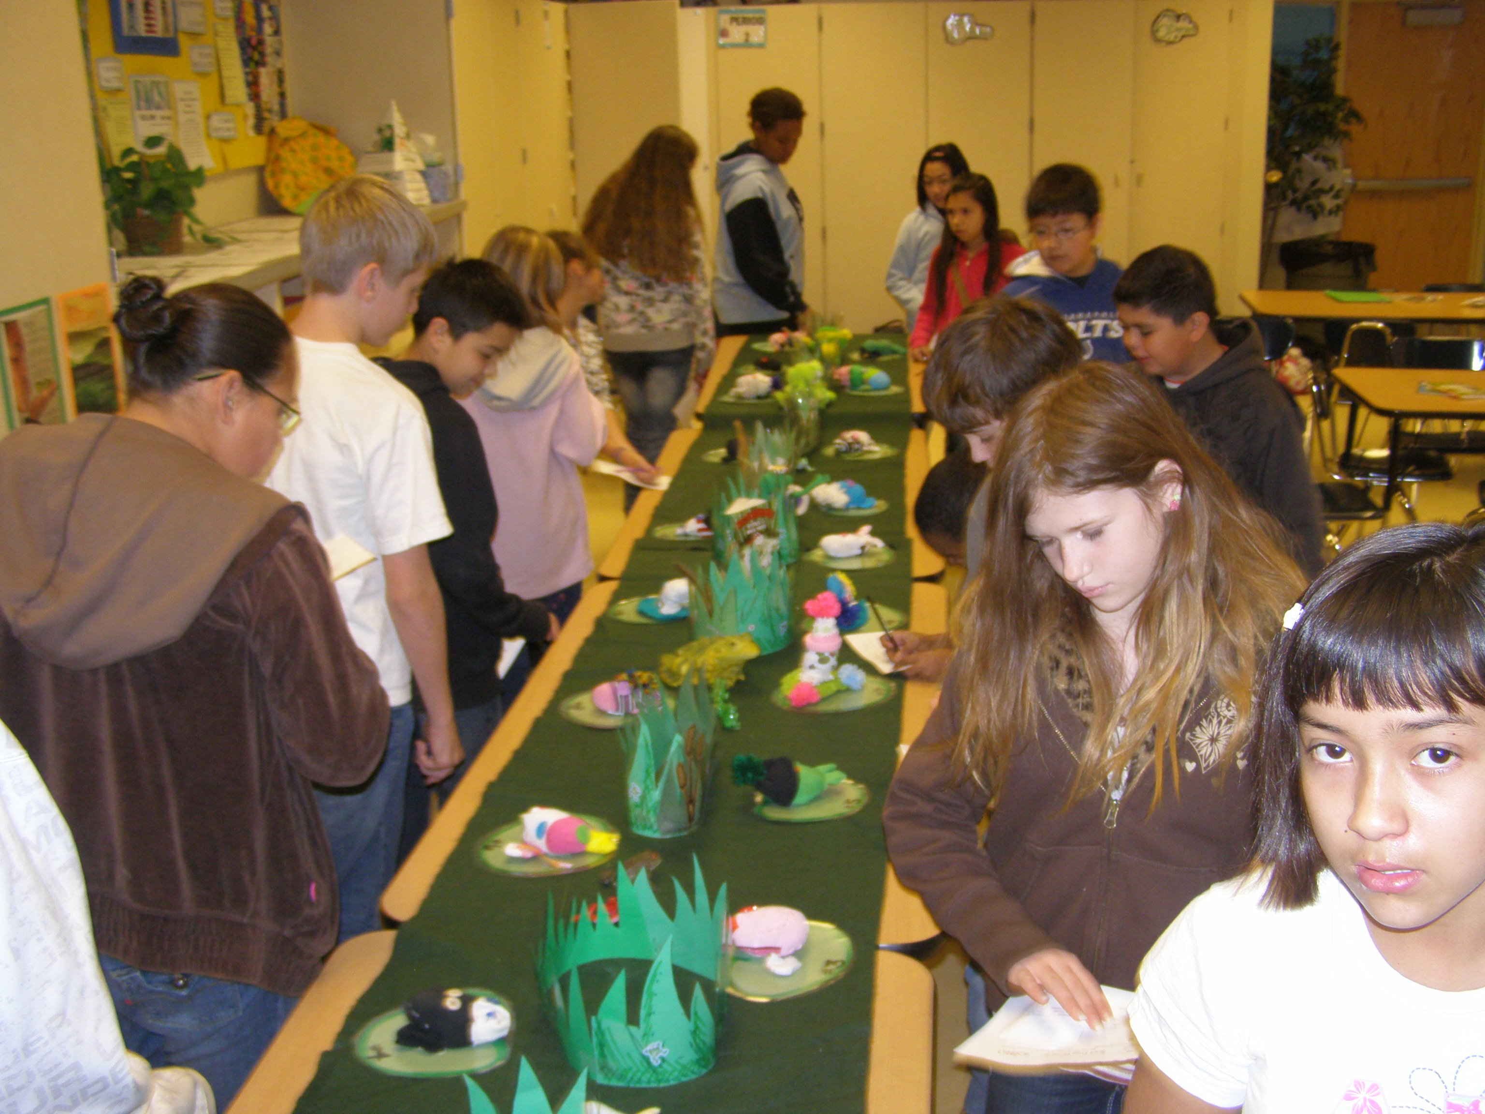 |  | Students voting of sock frogs which sit on laminated lily pads. Grant Middle School

