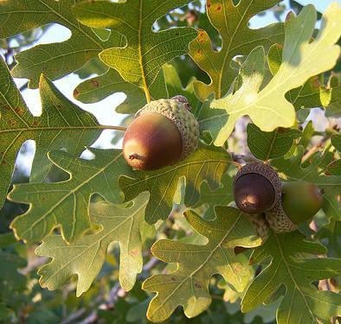

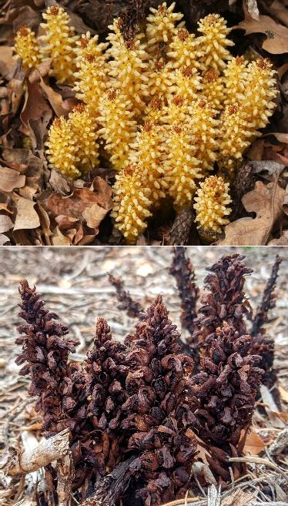
Oak tree & acorns (2 points)
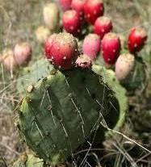
Prickly Pear cactus (2 points)
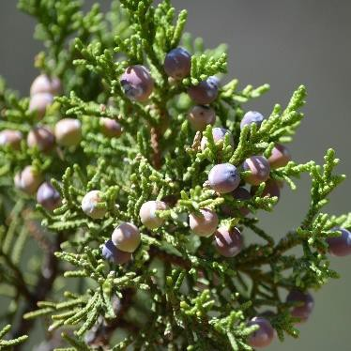
Juniper tree & berries (2 points)
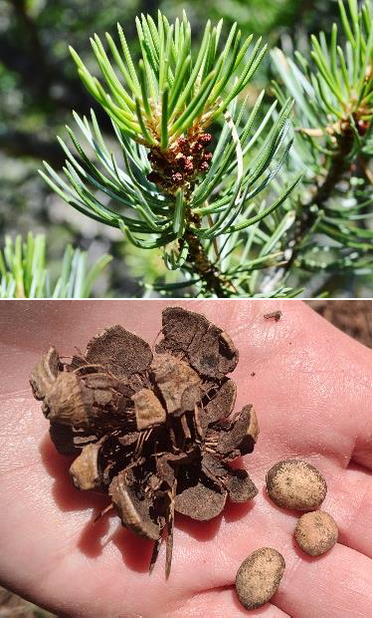
Piñon pine tree & piñons (2 points)

Bear Corn (2 points)
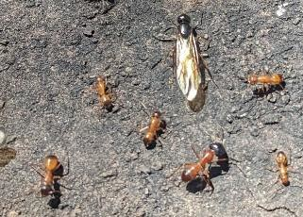
Ants and other insects (2 points)
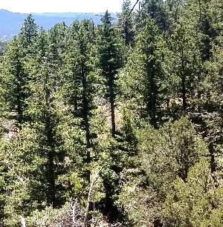
Mixed Conifer forest (more than 1 evergreen species) (2 points)
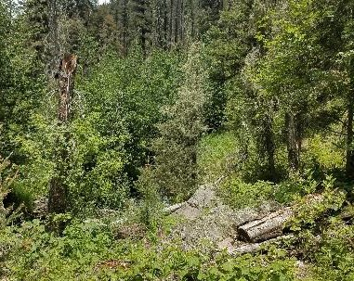
Thick understory (2 points)

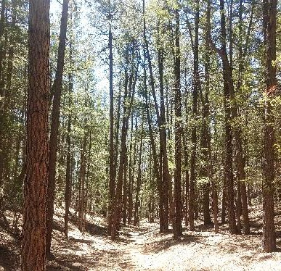
Tall trees (over 25 ft) (2 points)
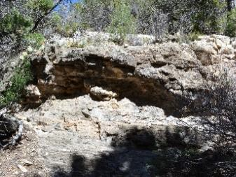
Rock ledges (2 points)
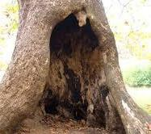
Tree cavity (1 point)
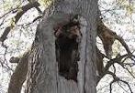
Elevated tree cavity (1 point)
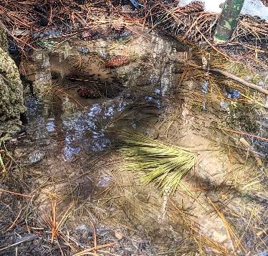
Water (4 points)

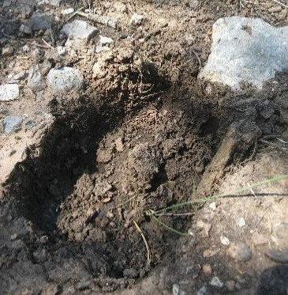
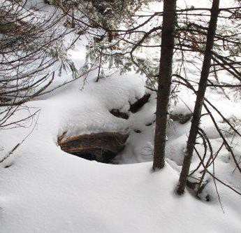
Bear Evidence

Add up your points!

Den Hole (6 points)
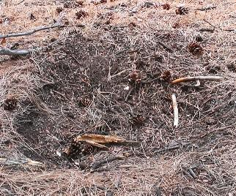
Day bed (2 points)
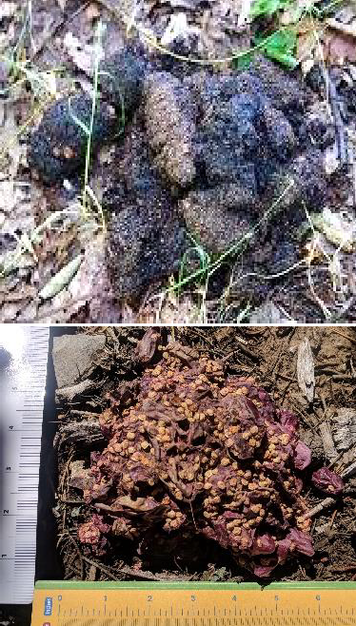
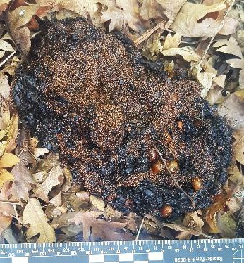
Scat (2 points)
Moved rocks (2 points)
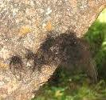
Hair on trees (2 points)
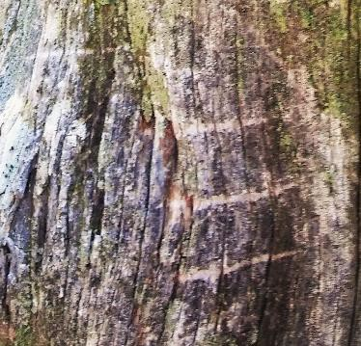
Scratches on trees (2 points)
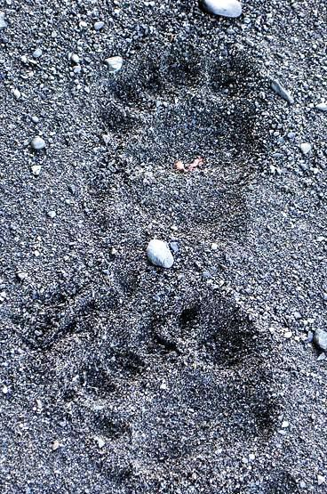
Tracks (2 points)
Total Points Is this a good bear habitat?
15 – 20 points:
Excellent Bear Habitat

10 – 14 points: Good Bear Habitat

5 – 9 points: Fair Bear Habitat

0 – 4 points: Poor Bear Habitat



