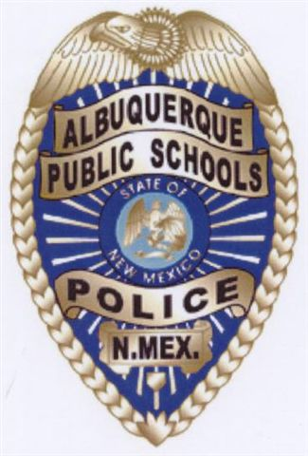
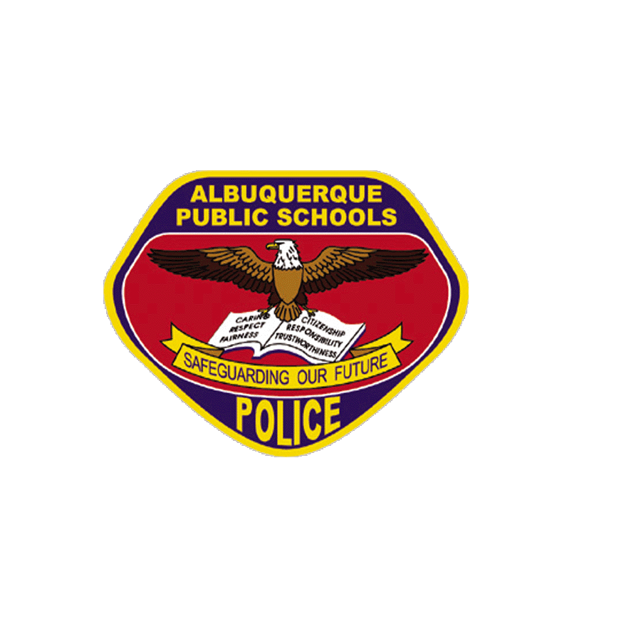
ALBUQUERQUE PUBLIC SCHOOLS
POLICE DEPARTMENT

REPORT REQUEST

6400 Uptown Blvd.
P.O. Box 25704
Albuquerque, NM 87125-0704
PHONE: (505) 243-7712 FAX: (505) 830-0110

DATE:____________________

NAME:________________________________

RELATION TO STUDENT (IF APPLICABLE):_____________________

PHONE #_____________________________

TYPE OF REPORT:_______________________________________________________

NAME(S) ON REPORT:___________________________________________________

DATE OF BIRTH:_________________

PLACE OF OCCURRENCE:_________________________LOCATION #___________

DATE OF OCCURRENCE:_____________

OFFICER’S NAME:_______________________________________________________

CASE #___________

POLICE APS E-MAIL ADDRESS: tackett_m@aps.edu
OUR FAX NUMBER (505) 830-0110 TELEPHONE NUMBER (505) 243-7712 EXT 14

XXXXXXXXXXXXXXXXXXFOR OFFICE USE ONLYXXXXXXXXXXXXXXXX

APPROVAL:______________________________________DATE:________________
RECEIVED COPY BY:______________________________DATE:________________
FEES:__________________________________________________________________

XXXXXXXXXXXXXXXXXXXXXXXXXXXXXXXXXXXXXXXXXXXXXXXXX

