Library Online Resources: Research, Information Literacy, and More
High School

The resources listed on this handout include the APS online library catalog and some of the databases APS high
school students can access. Most only require passwords when not on campus.

Destiny (Library Catalog)

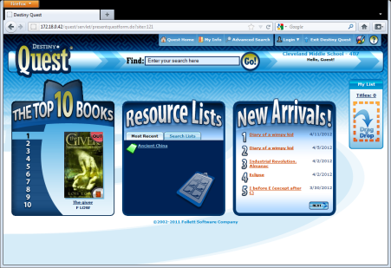
District-wide online library catalog, including e-books; also searches research databases.
Go to: http://library.aps.edu/
Username: s + student id #/ e + employee id # / Password: SSO/email password
Find the app: Destiny Quest

ABC-CLIO | Encyclopedia Britannica Image Quest
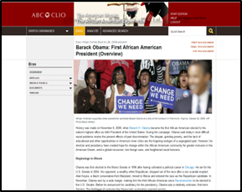 | 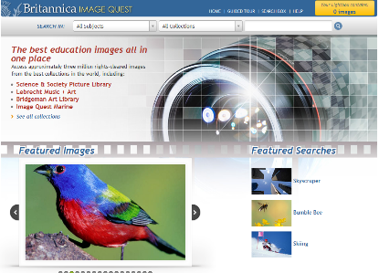
Social Studies articles, analytical debates, and in-depth explorations of key topics.  Go to: http://databases.abc-clio.com | Thousands of school-appropriate, copyright safe images, with citations.  Go to: http://quest.eb.com
Britannica Online | NewsBank
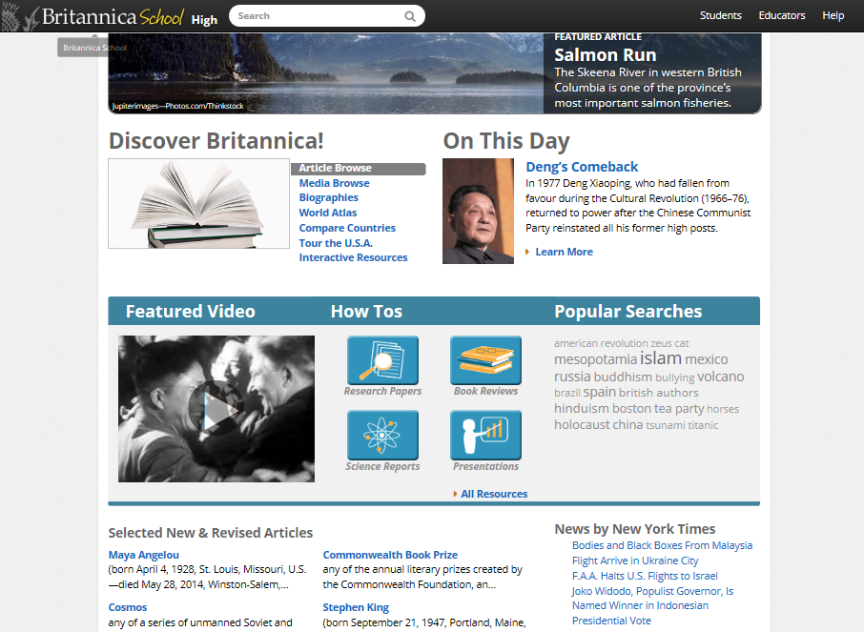 | 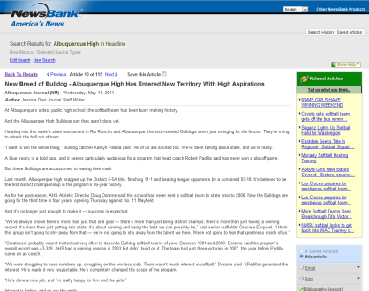
English and Spanish encyclopedia articles.  Go to: http://school.eb.com/levels/high | New Mexico newspapers online; also selected news articles on topics of current interest.  Go to: http://infoweb.newsbank.com
The NM State Library provides access to more than 30 databases; the six below are some of the best for high school. Students can use them individually, or search them all at once with Powersearch.

Special features: Translate articles into twelve languages; text-to-speech.
Go to: http://galesites.com/menu/albu29683 (or check with librarian/school website)
Find the app: Gale My School Library
Virtual Reference Library | Student Resources in Context
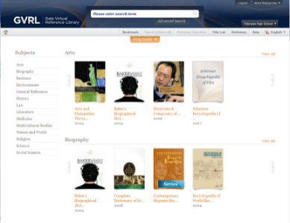 | 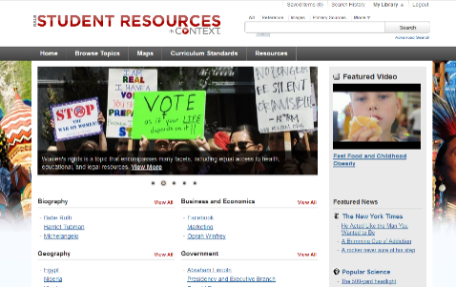
Reference eBook collection. | General comprehensive research resource—books, magazines, journals and primary sources.
Opposing Viewpoints in Context | U.S. History in Context
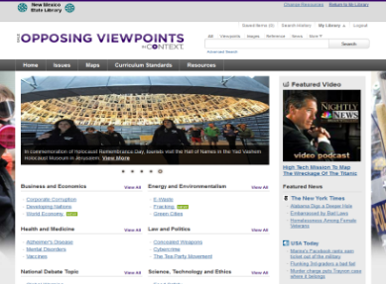 | 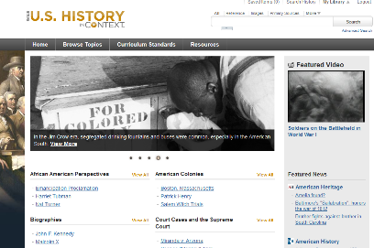
In-depth coverage of controversial topics. | U.S. History research resource—books, magazines, journals and primary sources.
Informe | Academic One File
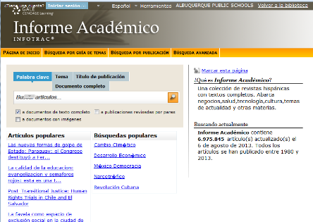 | 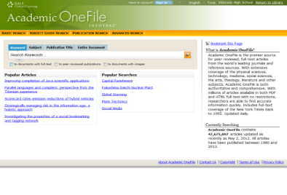
Reference and general interest newspaper and magazine articles in Spanish. | Scholarly journal and magazine articles.

For more information, visit Library Services online: http://www.aps.edu/libraries.
Ray Maseman, Digital Resources Specialist | 848.8882 | maseman@aps.edu

