Textbook Staging Guide

Staging is everything that needs to be done with textbooks to prepare them for inventory; specifically, collecting, centralizing, sorting, consolidating, removing book covers/sleeves, and stacking them. Please use this guide to help you properly prepare for the upcoming textbook inventory—you may find it helpful to follow our recommended preparation schedule at the end of this guide.

Home Base for the Inventory Team
The inventory team needs a secure room to base themselves out of during their time in your school. It does not need to be anything fancy—a conference room, underutilized classroom, a closet. The project manager may work out of this room, but for the most part, we’ll keep our things in this location and our equipment charging.
WiFi – If your school has a wireless network, it is VERY HELPFUL for the project manager to have access to the internet. Please provide a guest username and password.

What is Being Inventoried?
Please see the Official Title List of textbooks that your district has chosen to include in this inventory.

Access to Centralized Locations
On the day of the inventory, the inventory team will need access to the centralized locations.

Step 1: Collecting Textbooks & Preparing for Inventory
The Inventory Team will need to catalogue and barcode ALL textbooks, Teachers’ Editions and other book types on the Official Title List. Each school and its staff will be responsible for inventorying and barcoding all textbooks that are not captured during the inventory—more captured now, means less work later!

Where are Books Currently Stored?
Administration will find it helpful to enlist the help of content area department heads to facilitate locating textbooks that have been stored.

Student-Distributed Books
You will need faculty to help facilitate students returning their assigned books to class. We ask that you require your students to bring their books back to school 5-6 days prior to your scheduled inventory. Administration can help faculty get textbooks back from students with:
- Robo-calls every day in the week preceding inventory,
- eUpdate/eAlert, and
- Signs in hallways, bathrooms and other high-traffic areas (see the provided ReturnTextbooksSign).

Step 2: Preparing the Books
- Remove boxed books from boxes
- Remove book jackets/covers
- Remove shrink wrap from books

Step 3: Centralizing
All textbooks must be moved into central locations. Each school may centralize books in a MAXIMUM of 3 locations. Books can be stacked on the floor or on tables. Please remove ALL chairs from central locations.
NOTE: If your school’s inventory is scheduled over multiple days, please plan for a separate central location that all books, which trickle in after the inventory starts, may be taken to be inventoried. We want to avoid late-arriving books being placed with books that have already been inventoried, and therefore missed.
We highly recommend centralizing books in the gymnasium, cafeteria, stage and/or underutilized classrooms. Assuming textbooks have been staged properly according to this Staging Guide, these rooms will be utilized for approximately 5-7 workdays. Consideration should be given to sports practice/events and custodial waxing schedules.

Who Might Be Recruited to Centralize the Books?
- Custodial Staff
- Faculty
- Content Area Department Chairs
- Students (teams, ROTC, teacher’s helpers, etc.)

Where are the Books Centralized?
When the inventory team arrives, they will need approximately 10 copies of the floorplan/map with the properly staged, centralized locations clearly identified.

Step 4: Setting Up Centralized Locations

Are Books Within Locations Accessible?
Please ensure that ALL textbooks are accessible within each location. This means:
- Adequate workspace is provided around books,
- NO furniture, boxes or other obstructions block the books, and
- A ladder is provided if books are stored on high shelves.

Adequate Workspace
Option 1 - Tables w/ NO Chairs: Line up six to eight foot tables throughout the center of the room with at least 3 feet around each side. Books may be stacked approximately 2 1/2 feet high in two rows of stacks. Leave 18” of empty space every 4-6 stacks/columns.
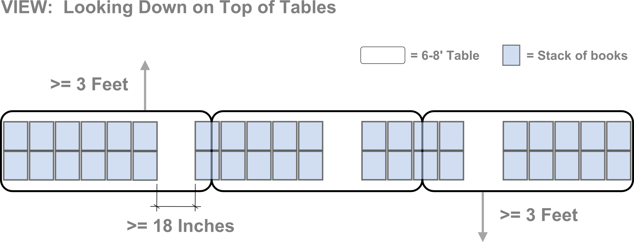

Option 2 - Floor w/ NO Chairs: Books may be stacked approximately 3 feet high, in rows of two throughout the middle of the room OR 1 row against a wall. There is a minimum of 2 feet in front of/around books and there is a minimum of 18 inches left open every 4-6 stacks of books.
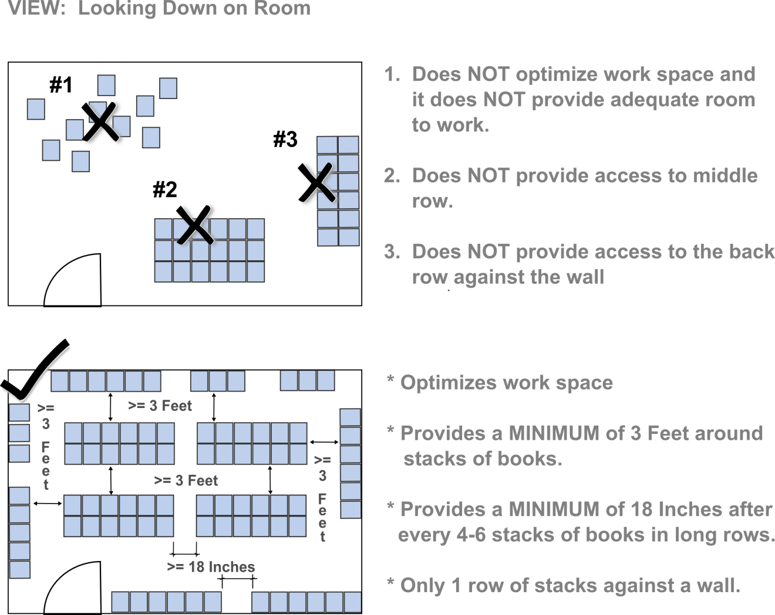

Properly Prepared Books
Books should be:
- accessible,
- removed from boxes or shrink wrap,
- stacked neatly without a bookcover/wrap,
- sorted and consolidated by same title,
- upside down, and CORRECTION: Please stack books right side up (cover facing the ceiling).
- with the barcode/ISBN number that is on the back cover facing you (the front).
NOTE: Teachers’ Editions are a separate title from that of the student edition.

Sorted by Same Title…

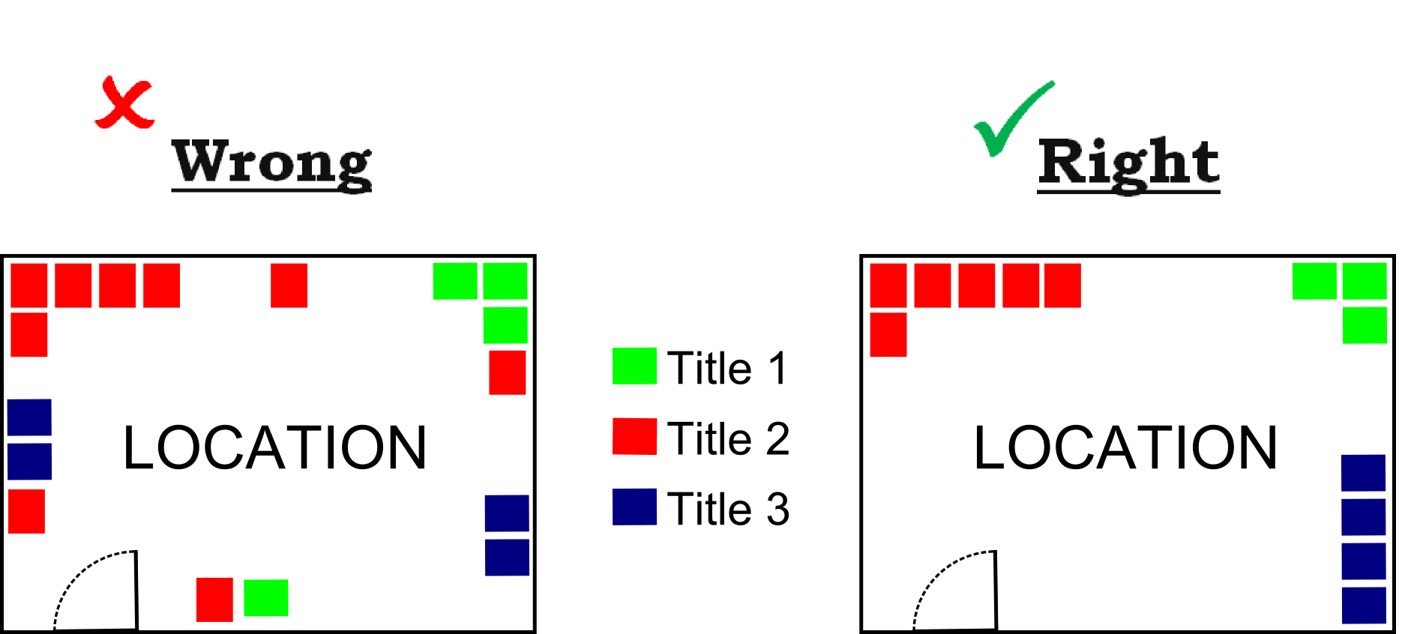
Consolidated by Same Title…

Stacked upside down with the barcode/ISBN number that is on the back cover facing front…
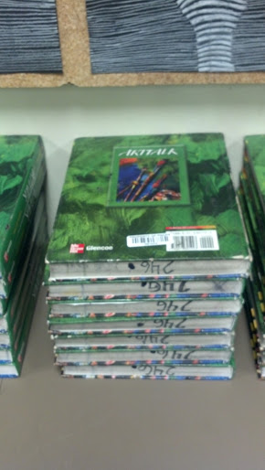
CORRECTION: Please stack books right side up (cover facing the ceiling) with the bottom facing front.

Book Stacking Take-Aways
The below photo serves as a great example of proper staging on the floor—think of the books being stacked in 2 rows and 7 columns (that are fully viewable). Some take-aways from the photo are:
- Stacked columns are no higher than approximately 2 ½ feet high
- Each column contains only ONE TITLE
- Titles are sorted and consolidated WITHIN THE SAME ROW
- 18+ Inches after 4-6 columns/stacks
NOTE: There does not need to be 18+ inches of space in between titles—just in between every 4-6 columns/stacks.

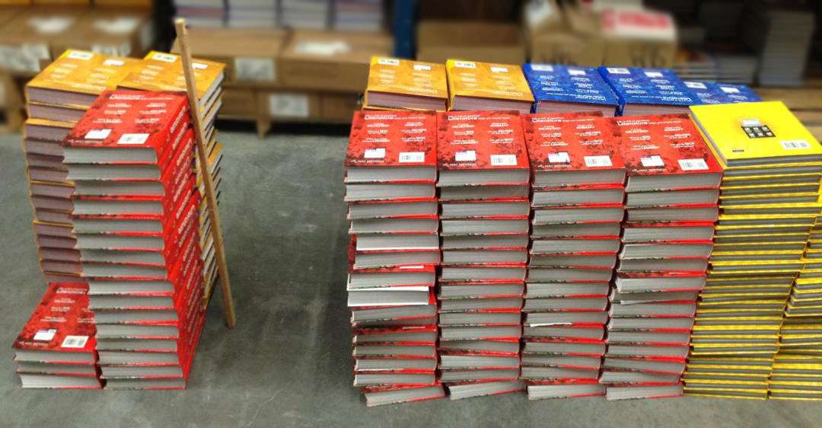

Recommended Preparation Schedule (During School Year)
Completed  On OR Before |  | Activity
17 | Workdays before inventory | - Notify Faculty, Custodial Staff, and Content Area Dept. Chairs  - Decide what rooms you will use as central locations  - Start locating/finding books currently in storage
15 | Workdays before inventory | - Notify Students & Parents  - Start centralizing books currently in storage
6 | Workdays before inventory | - Books Due: Collect Books from Students
4 | Workdays before inventory | - Centralize Books
2-3 | Workdays before inventory | - Contractor will come to inspect central locations for adherence to THIS staging guide (72-48 hours before inventory).
0 | Workdays before inventory | - Inventory (Most inventories will be completed in a day but they may be moved 1 day before or after your scheduled inventory)

Recommended Preparation Schedule (Summer)
Completed  On OR Before |  | Activity
10 | Workdays before inventory | - Notify Faculty, Custodial Staff, and Content Area Dept. Chairs  - Decide what rooms you will use as central locations  - Start locating/finding books currently in storage
4 | Workdays before inventory | - Centralize Books
2-3 | Workdays before inventory | - Contractor will come to inspect central locations for adherence to THIS staging guide (72-48 hours before inventory).
0 | Workdays before inventory | - Inventory (Most inventories will be completed in a day but they may be moved 1 day before or after your scheduled inventory)

