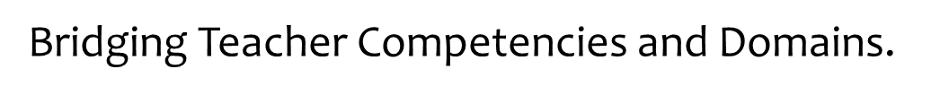

Bridging The Common Core To The Domains

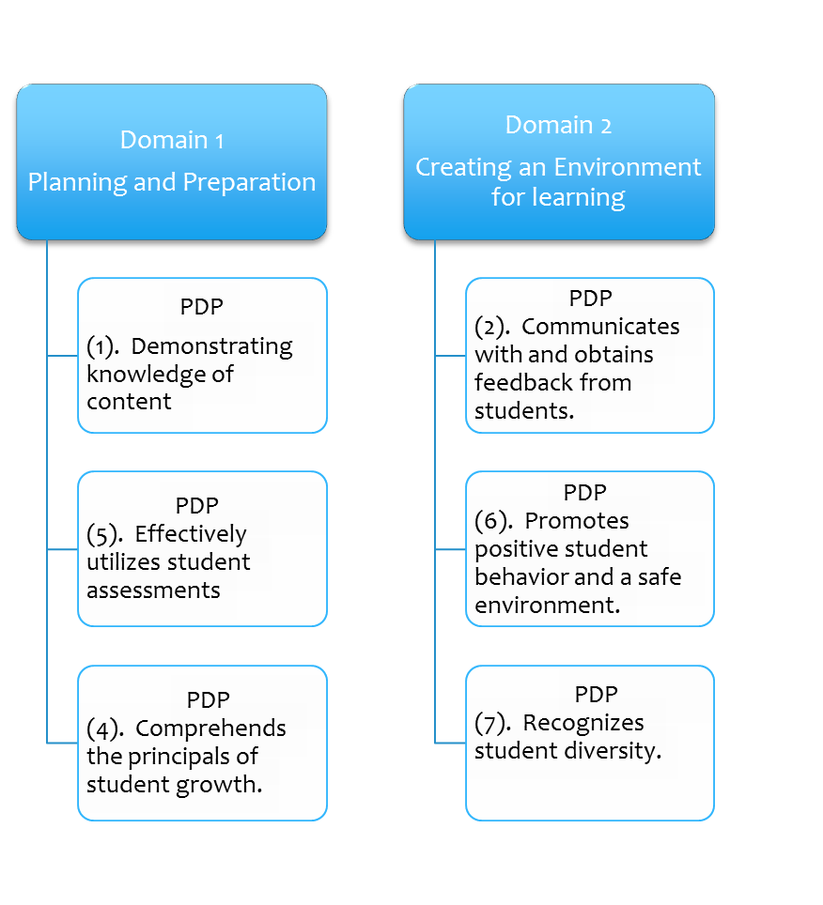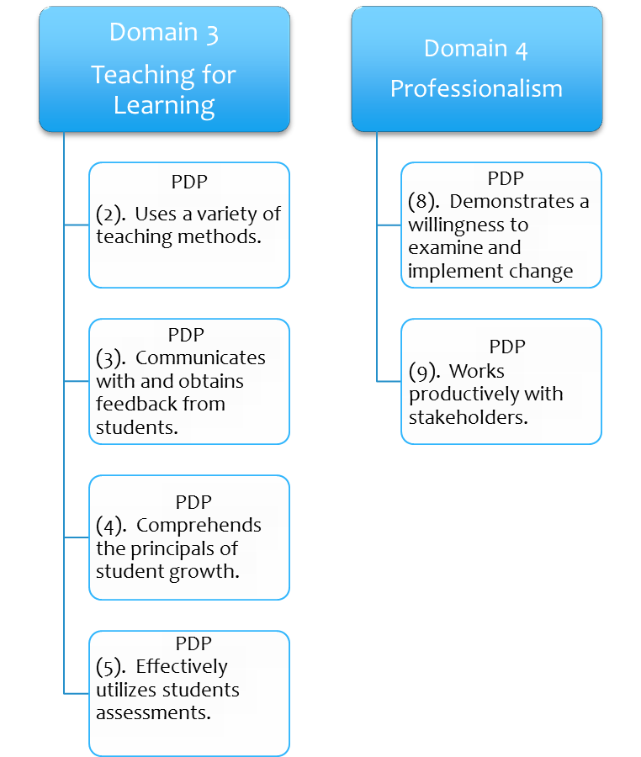

Develops differentiated, content integrated lesson plans.

Effective use of

PLC time

Uses CCSS Lesson Plan Templates

Implements flipped

instruction models

When appropriate

Provides practical application/

practice in a hands--on environment

Knows names, faces, cultures, abilities, needs, circumstances of students

Provides evidence of high expectations

(with necessary accomomdations, modifications, sheltering)

Employs Gradual Release

Strategies

Focus on Informational Text

Regularly Implements DOK level of 2 or more in instruction

Shares team burden of CCSS Implementation

Engages in on-going CCSS PD from a variety of sources

Engages in on-going

reflection of instructional practices

Focus on Informational Text

Implements DOK levels of 2 or more in instruction

Some elements fit into more than one domain Domain.