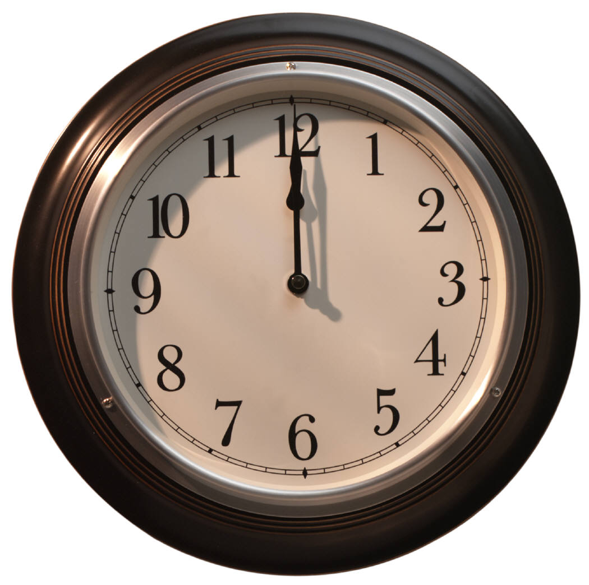

***APPOINTMENT CLOCK***

***Create an appointment for each of the four times provided. Make sure you have a different name on each line.***