Albuquerque Public Schools

**For additional information please contact:**

**Curriculum and Instruction:**

**Map Hotline:**[curriculummaps@aps.edu](mailto:curriculummaps@aps.edu)

Karen White, Instructional Manager 872-6879

Margie Maes, Resource Teacher/On-Line Developer   
880-8249 ext. 235

Elaine Killingsworth, Secretary

872-6867

**For information on DBA**:

**DBA Hotline:**<DBA@aps.edu.>

**Your Questions Answered**

## Curriculum Maps *via* Blackboard

## & AIMS

## 

Bl



Aps.blackboard.com

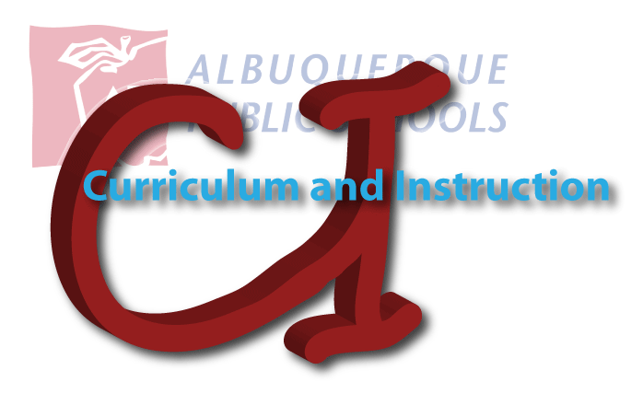

# Curriculum & Instruction



### Where do I find the Maps?

**Blackboard:**

Go to <https://aps.blackboard.com>  
  
You may view information and download maps on this site ***without logging in.*  
NOTE:** However, in order to use this site for other applications you will need to login using your APS email username and password.   
Once you are in the site:

* Click on Curriculum and Instruction, under “Lists of Departments”. You will then see the C & I home page.
* Click on Curriculum Maps/Frameworks; once on the Curriculum Maps page scroll down until you see your options for grade level maps.
* Click on the level then the  
  subject, then the specific map needed.

C:\Documents and Settings\elaine.killingsworth\Local Settings\Temporary Internet Files\Content.IE5\DQRRTW5X\MC900384172[1].wmf

**NOTE:** You should see blue buttons on the left hand side of the screen. If you don’t see these buttons; there is a small white arrow on the left side; click on this in order to open up the buttons.

**NOTE:** If you have a problem with the pop-up blocker, just allow the download by clicking on the bar at the top. It may send you back out to the home page and you will need to repeat the previous steps in order to open the map.

**AIMS:**   
Go to <https://aims.schoolnet.com>

* You must log in to AIMS in order to download curriculum maps
* Curriculum maps are located  
   on the left side of home page
* Click on specific map to get to  
  downloadable link (in blue)

**NOTE:** User name and password are generated by AIMS   
Forgot password - click on *Forgot your password?* on login page. A new password will be emailed to your APS email account   
Call help desk at 830-8080 if you still have access problems

**Additional Resources:**

**On Blackboard:**  
Curriculum Maps Powerpoint  
Extended Pacing Guides  
Summer Updates 2010

C:\Documents and Settings\elaine.killingsworth\Local Settings\Temporary Internet Files\Content.IE5\Z67F57D9\MC900363872[1].wmf